**Initial Flashing Guide**

Table of contents

1. Objective 3

2. Prerequisites 4

3. Fuse Bits 5

4. Flashing 6

4.1. ZB-ANA/ZB-485 6

4.2. ZB-HART 8

1. Objective

This document describes how to setup and flash relevant firmware/bootloader for initial board setup at factory.

1. Prerequisites

The following H/W and S/W are required to setup boards and flash relevant firmware.

* ATMEL ICE   
  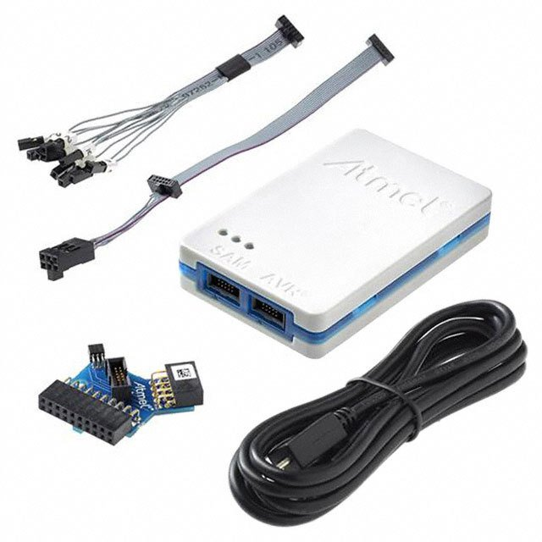

*Note: Although AVR ISP can be used for the setup/flashing work, it isn’t clear at the moment whether ZB-HART will shipped with ISP headers attached on the board. So in this document, everything is described assuming that ATMEL ICE is used for the setup works.*

* ATMEL Studio 7



*Note: Any AVR Flashing Program that supports ATMEL ICE JTAG/ISP interface can be used. But in this document, for convenience’s sake, everything is written assuming that ATMEL Studio 7 is used for the setup works.*

1. Fuse Bits

For proper bootloader operation, Fuse bits for HART/ANA/485 boards should be set up as described in the following pictures.

For ZB-HART(ATMEGA 1280) and ZB-ANA/ZB-485(ATMEGA 1281)

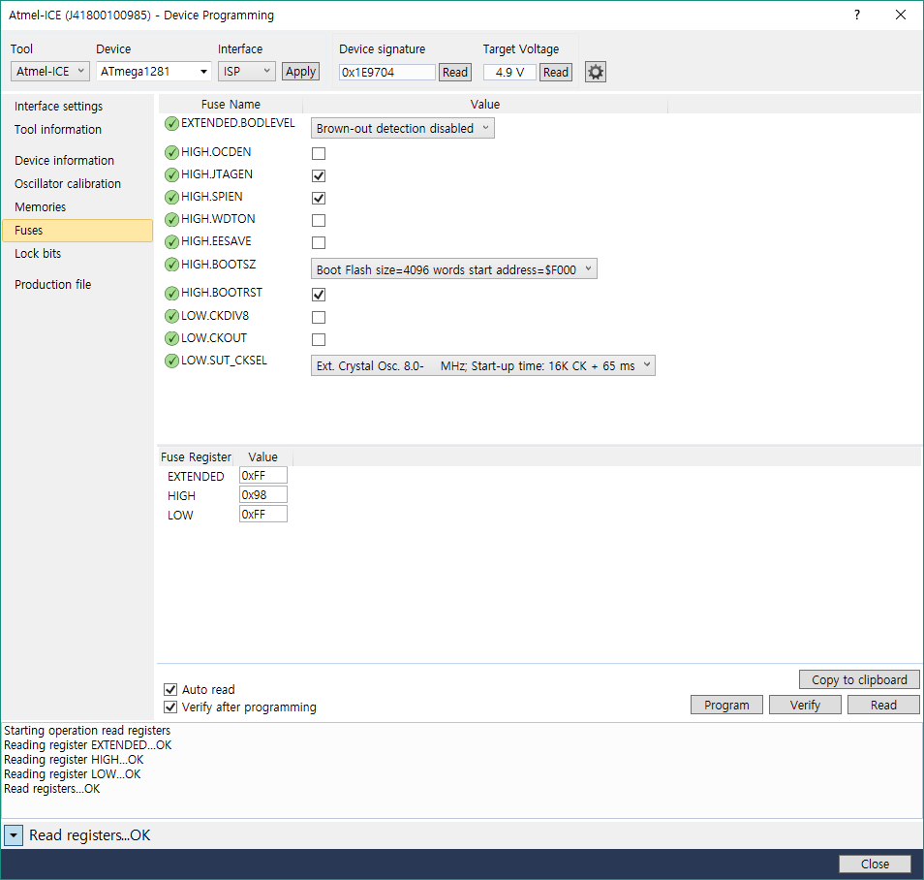

1. Flashing
   1. ZB-ANA/ZB-485
2. Chip Erase

Click Erase now to erase the whole chip

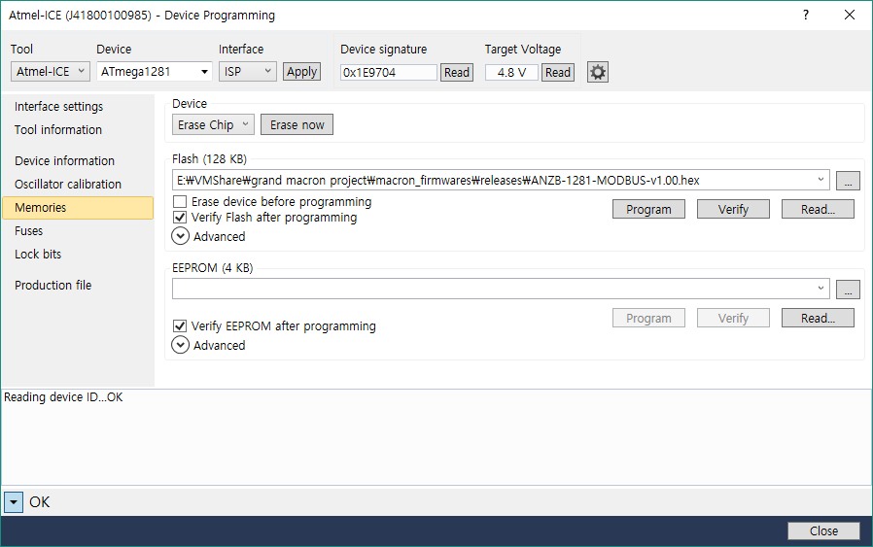

1. Choose

ANZB-Bootloader-1281-v1.00.hex

1. Flash Bootloader

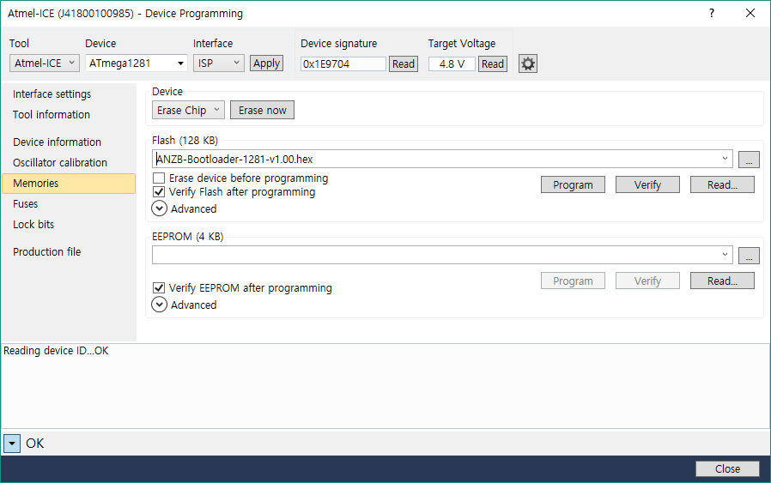

2. Click Program

1. Flash Firmware

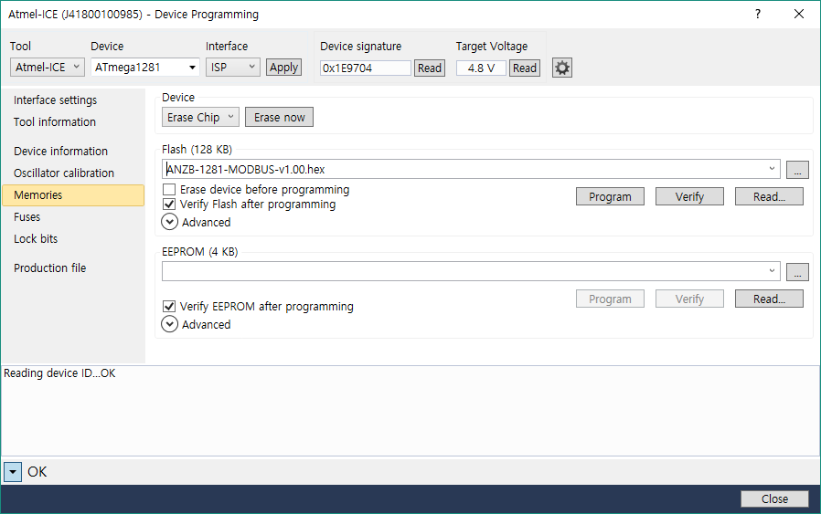

2. Click Program

1. Choose

ANZB-1281-MODBUS-v1.00.hex

* 1. ZB-HART

1. Chip Erase

Click Erase now to erase the whole chip

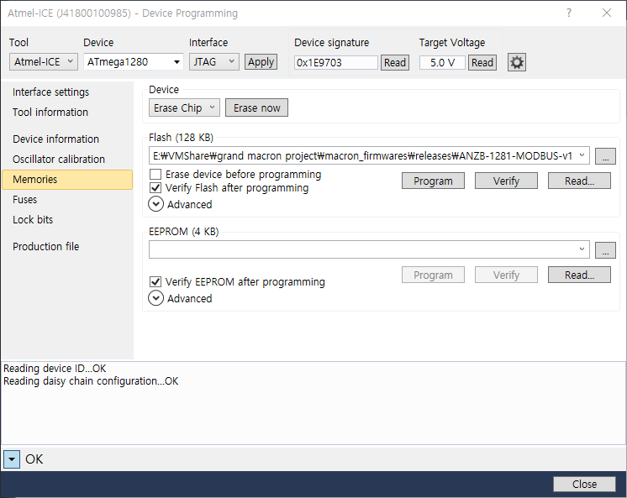

1. Flash Bootloader

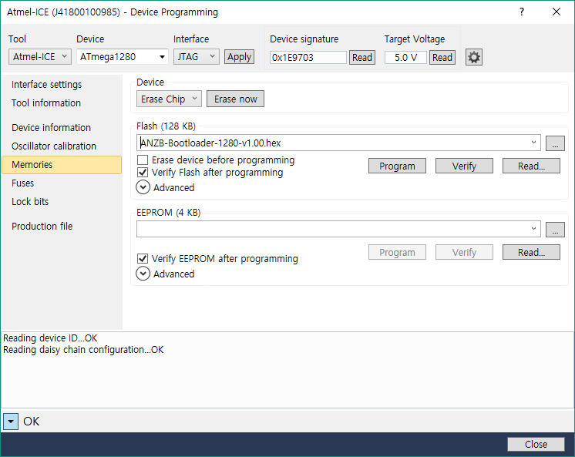

2. Click Program

1. Choose

ANZB-Bootloader-1280-v1.00.hex

1. Flash Firmware

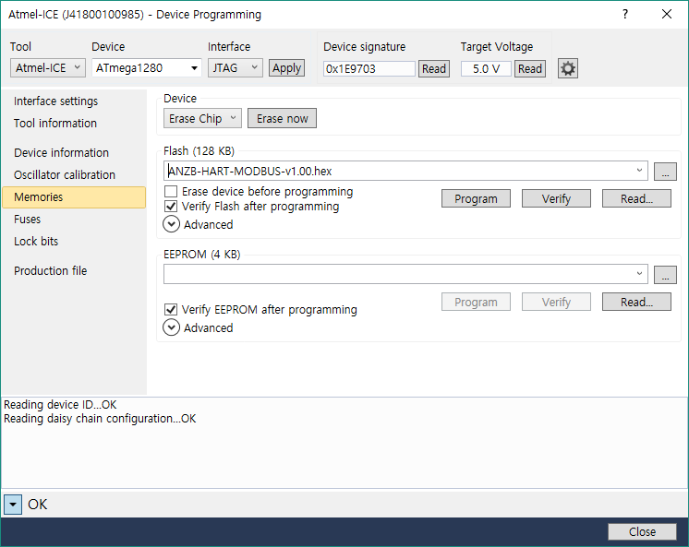

2. Click Program

1. Choose

ANZB-HART-MODBUS-v1.00.hex